**POC for Twitter social media sentiment analysis and Data Pipeline**

**Description**-

Sentiment analysis is the process of determining the sentiment or emotion expressed in a piece of text, such as a twitter post. This can be useful for businesses to gauge customer satisfaction, monitor brand reputation, and inform marketing strategies. In this project, we will use machine learning techniques to analyze sentiment in social media data as well as created in the implementation approach of datapipeline methodologies

**High level Architecture-**

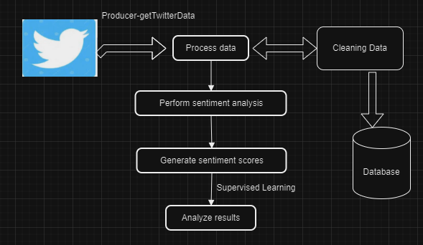

To create a Proof of Concept (POC) for reading **social media sentiment** and performing data transfer and load for data science purposes, we can break down the steps into the following phases:

**Extract Data**: Collect data from social media platforms (e.g., Twitter) using APIs.

**Analyze Sentiment**: Use a Natural Language Processing (NLP) model to analyze sentiment.

**Transform Data**: Clean and preprocess the data for analysis.

**Load Data**: Store the processed data into a data store or database for further analysis or visualization.

We'll implement this using Python with libraries such as for extracting Twitter data, TextBlob or VADER for sentiment analysis, and pandas for data manipulation. Additionally, we’ll use SQLAlchemy to load the data into a database.

**Prerequisites**

* **Twitter Developer Account**: To access Twitter data, we need API credentials from a Twitter Developer account.
* **Python Environment**: Python 3.x installed with libraries (, pandas, TextBlob, SQLAlchemy).

**Step-by-Step Implementation**

**Step 1: Install Required Packages**

Install the required Python packages:

pip install pandas textblob SQLAlchemy

**Note**-Use the requirement.txt file for install in a on shot

**Step 2.1 : Extract Data from Twitter with Security layer**

Use tweepy to fetch tweets based on a keyword or hashtag.

Path -[data/collect_data.py]

**Description - Extract data** from Twitter using the library

**Step 2.2 : Extract Data from Twitter with Security layer**

Use tweepy to fetch tweets based on a keyword or hashtag.

Path -[data/DataByNitter.py]

**Description - Extract data** from Twitter using the Nitter and ntscraper library which is latest release

**Step 3: Perform Sentiment Analysis**

Use TextBlob to analyze the sentiment of the tweets.

Path -[model/preprocess_data.py]

**Description**- **Analyze sentiment** using TextBlob

**Step 4: Transform and Clean Data**

Clean the tweet text by removing URLs, mentions, and special characters.

Path -[transform/clean.py]

**Description**- **Transform and clean** data using Python's re module

**Step 5: Load Data into a Database**

Use SQLAlchemy to load the processed data into a database (e.g., SQLite, PostgreSQL, etc.).

Path [load/target.py]

**Description**- **Load the processed data** into a database using SQLAlchemy.

**Step 6: Transfer Data for Data Science Tasks**

After the data is loaded into a database, you can perform additional data science tasks, such as visualization, machine learning, or advanced analytics.

Using **pandas** to query the data:

Python

|  |
| --- |
| # Read data back from the database  loaded_data = pd.read_sql('SELECT * FROM tweets', con=engine)  print(loaded_data.head()) |

**Step 7: Visualization (Optional)**

Visualize the sentiment analysis results using matplotlib or any other visualization library.

Python

|  |
| --- |
| import matplotlib.pyplot as plt  # Count sentiment values  sentiment_counts = tweets_df['Sentiment'].value_counts()  # Plot sentiment distribution  plt.figure(figsize=(6, 4))  sentiment_counts.plot(kind='bar', color=['green', 'red', 'gray'])  plt.title('Sentiment Analysis of Tweets')  plt.xlabel('Sentiment')  plt.ylabel('Count')  plt.show() |